School Of computing

Practical 2.1: Node.js & VS Code

What you will learn / do in this lab

- Download and install node.js & Visual Studio Code (VS Code)
- Configure Visual Studio Code to work with node.js
- Write the first computer program using JavaScript
- Run a program
- Write a program that can display output on the integrated console of VS Code
- Write a program that can accept keyboard input from users
ST0502 Fundamentals of Programming
1) Download node.js & Visual Studio Code

- Access this URL to download node.js (choose the version that is compatible with your laptop):
https://nodejs.org/en/download/
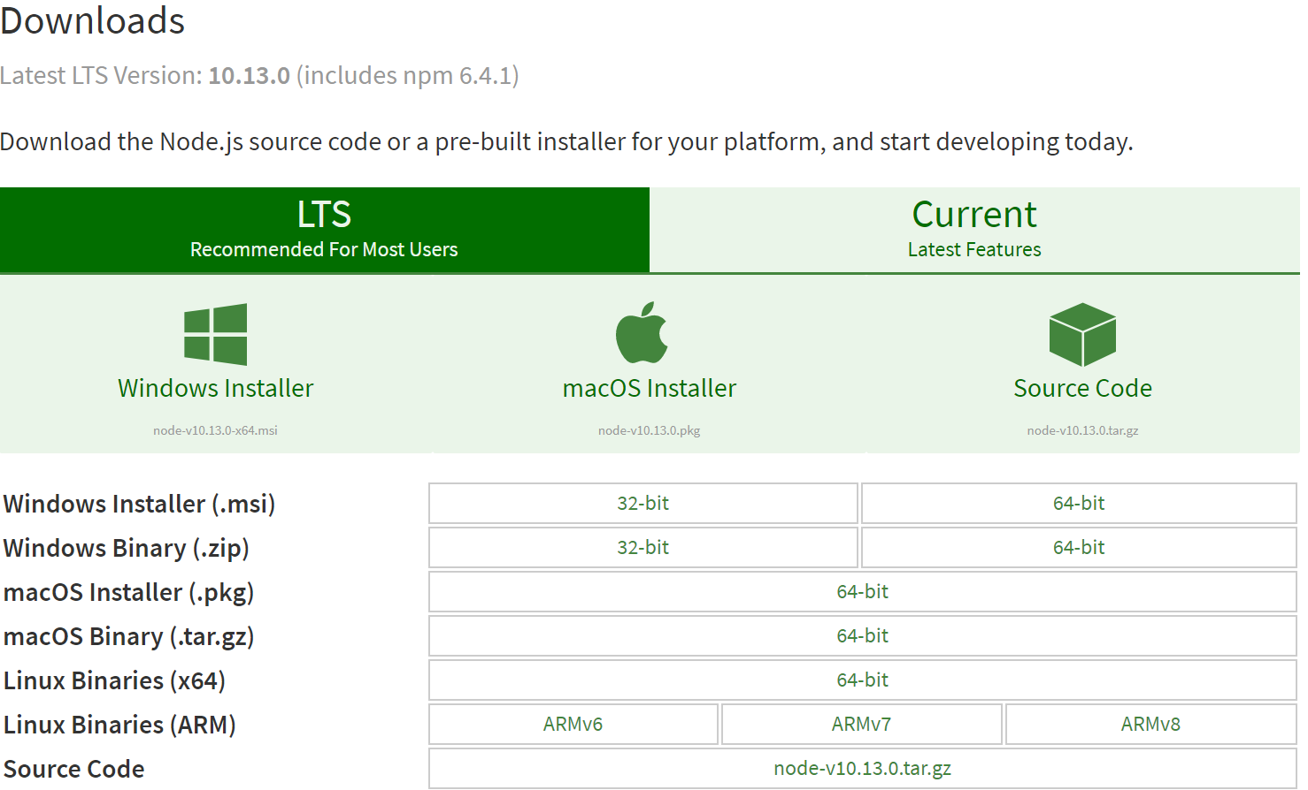

- Install node.js. You can accept all default options during the installation process.

- Access this URL to download Visual Studio Code (choose the one that is compatible with your notebook): https://code.visualstudio.com/download
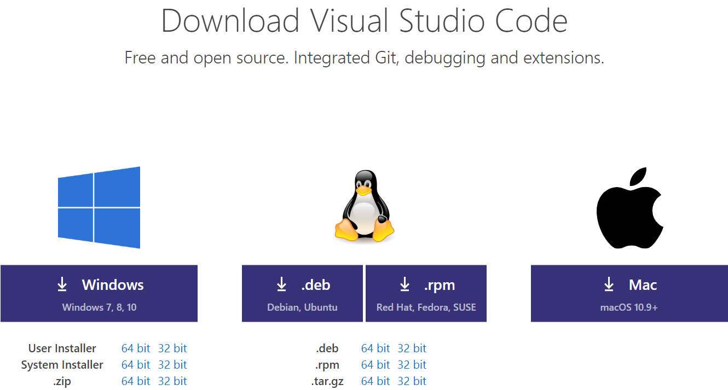

- Install VS Code. You can accept all default options during the installation process. For windows user, note that ‘System Installer’ is for the users who has full administrative right to their PC, whereas ‘User Installer’ is for those without.

2) Launch Visual Studio Code:
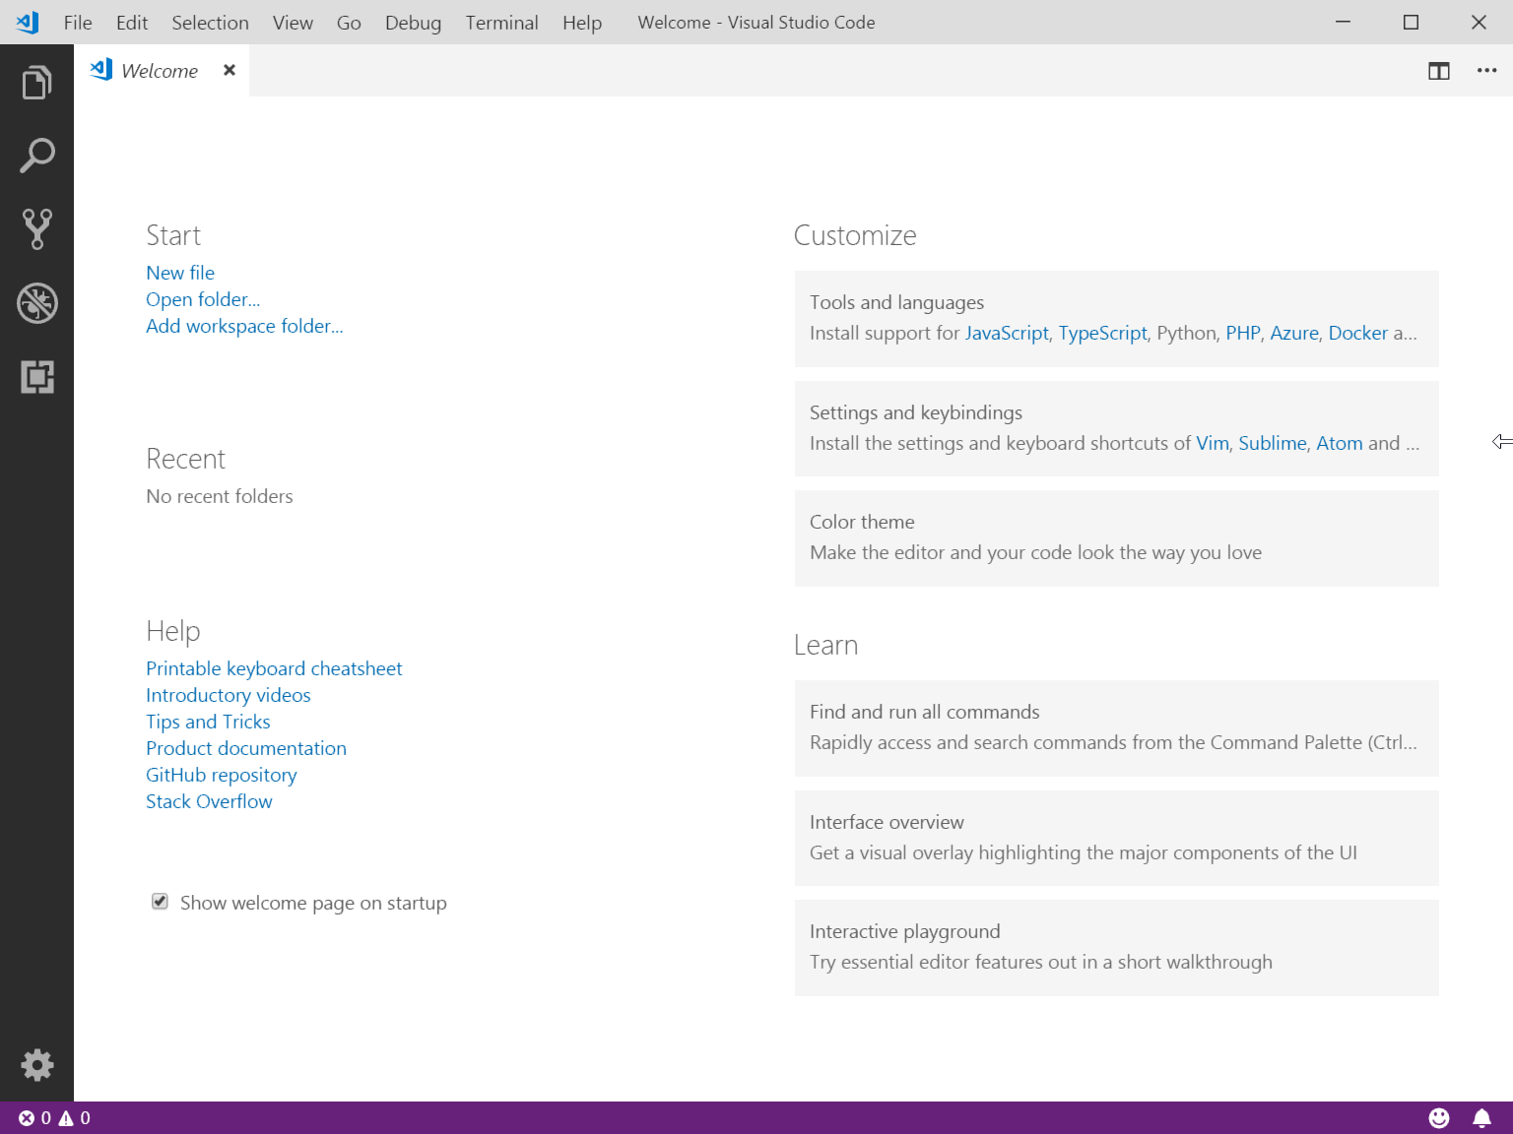

- Create a new folder in your hard drive, called "FoP" e.g. C:\FoP\
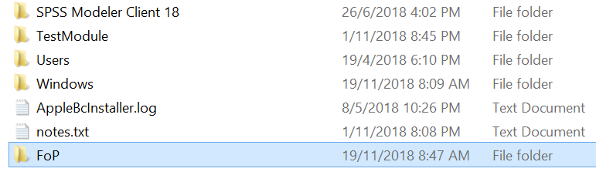
- In VS Code, From the menu, choose View → Explorer to show the Explore side bar:
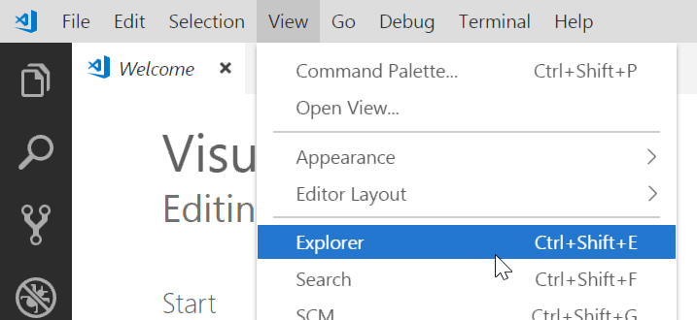

- Click "Open Folder " button on the left pane of the screen. Choose FoP folder that you have just created in the previous step.
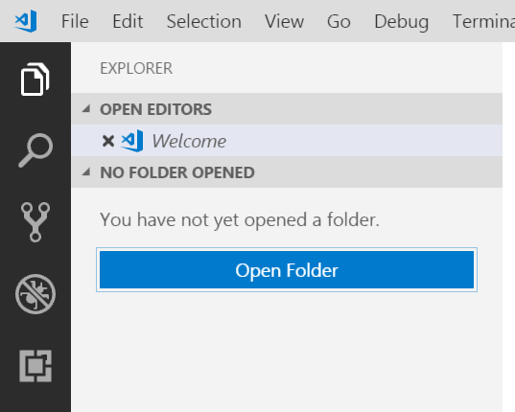

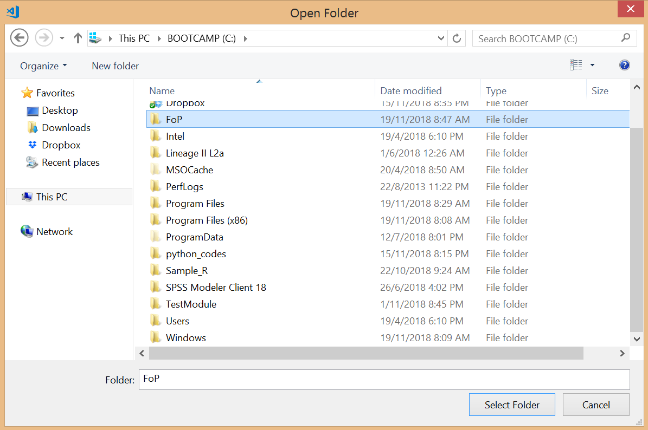

- From the menu, choose Debug → Open Configuration, then select "node.js". Visual Studio Code will then open launch.json, which is the configuration file for all your programs.
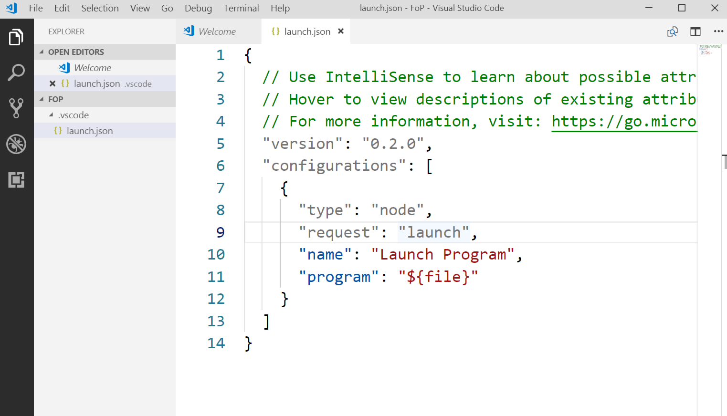

- Add in the following configuration command:

"console": "integratedTerminal"

Your launch.json should look like this:
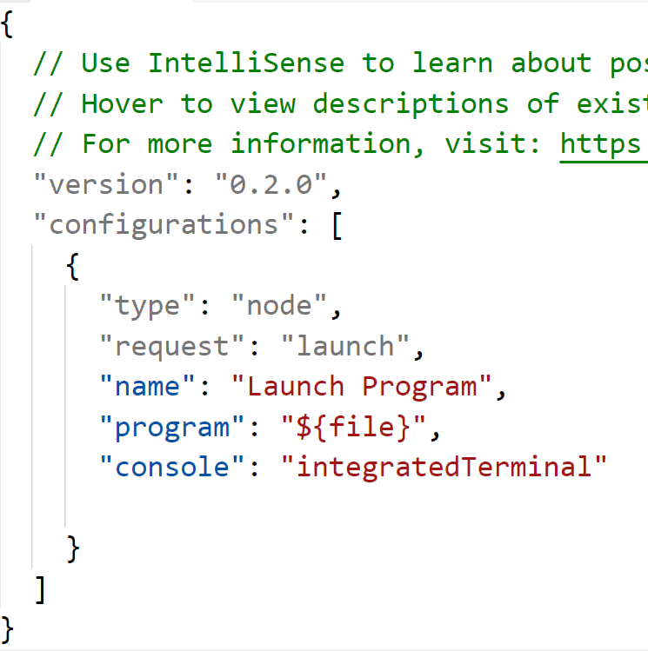
Remember to put in a ‘comma’ here
This is the line you type in

Save the file (File → Save or CTRL + S). This will enable your VS Code to use its integrated terminal to run the programs.

- From main menu, choose View → Terminal. A terminal window will be displayed at the bottom area of the screen as shown here:
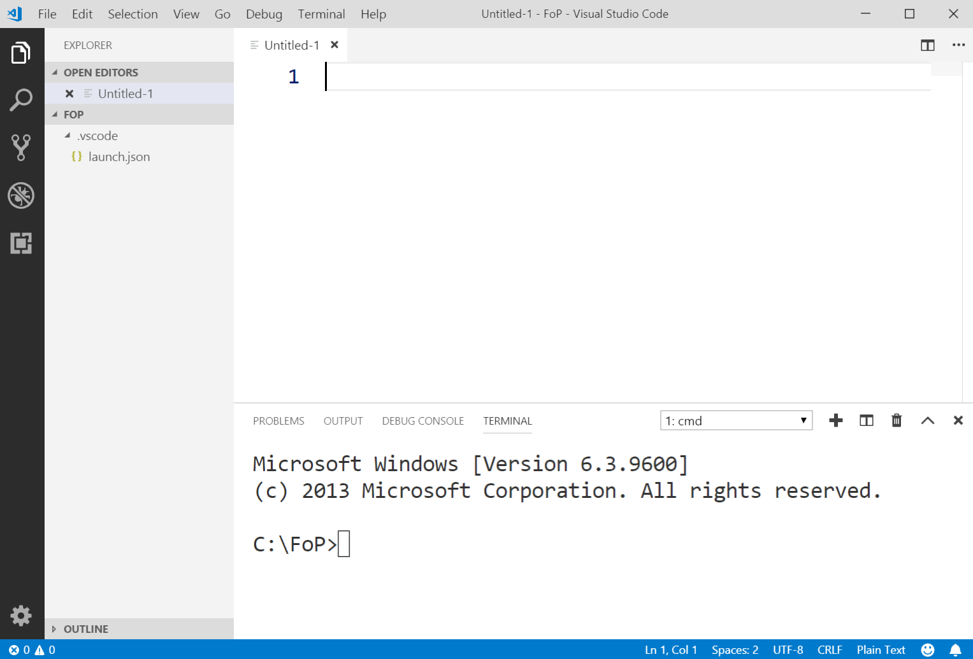

Type in the following:

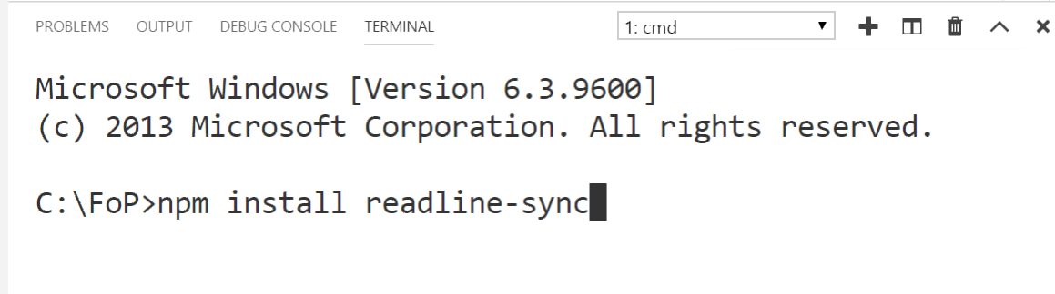

npm install readline-sync

and press enter. The readline-sync module, which is a module that allows you to accept keyboard input from the user will be downloaded & installed for all programs that will be created in your FoP folder.
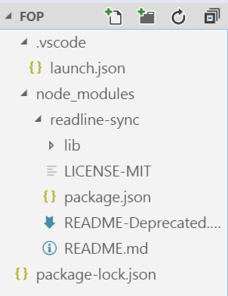

2. Create and run a JavaScript program.

- Right click on "New Folder" icon on FoP folder in the Explorer side bar:
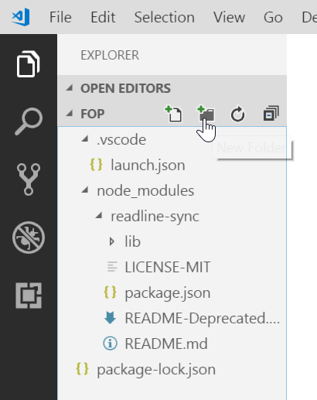

- Name the new folder to "Practical02" to reflect the practical work we are working on (for Practical 3, you should also create another folder called "Practical03").
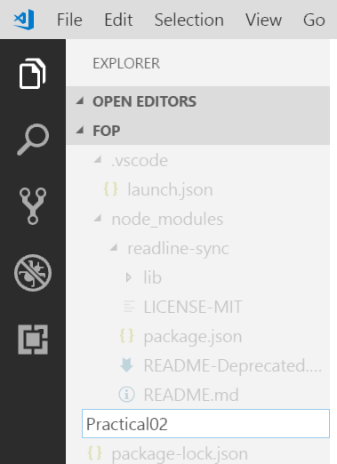

- Right click on "Practical02"folder and choose "New File" from the pop-up menu.
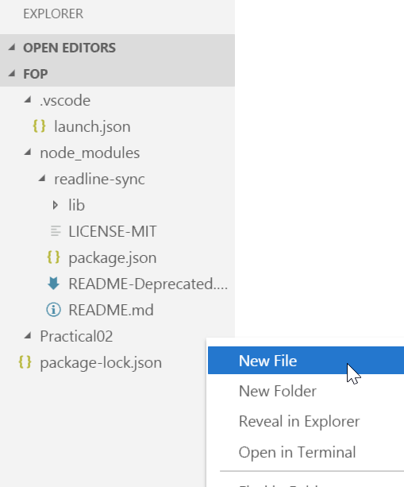

- Rename the file to "myFirstProgram.js" (Always use js extension for all JavaScript files).
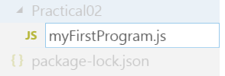

- Type in the following code in the editor window:
console.log("Welcome to Fundamentals of Programming");
console.log("This is my first program!");

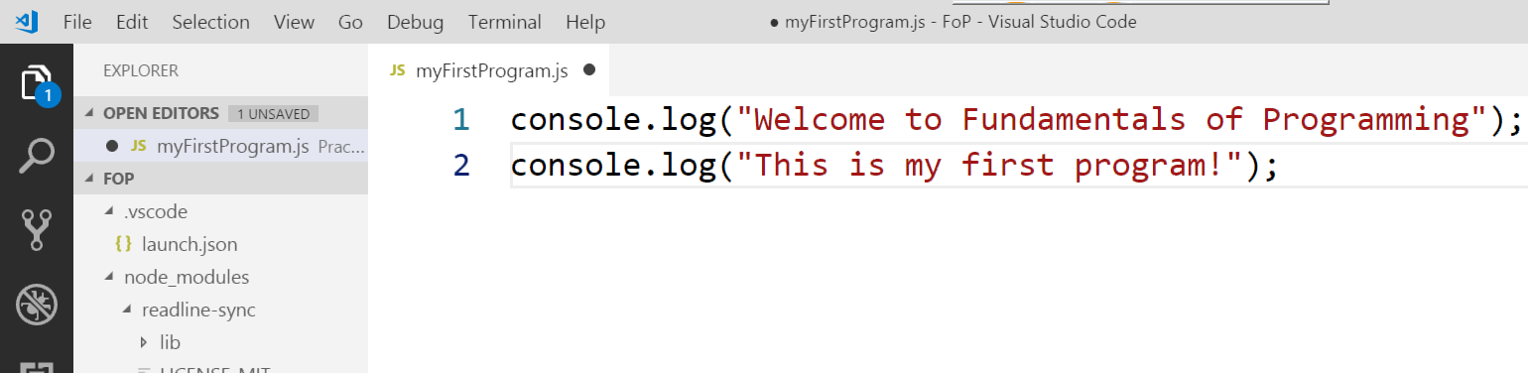
- You can run your program by choosing Debug → Start Debugging, or simply press F5 on your keyboard.
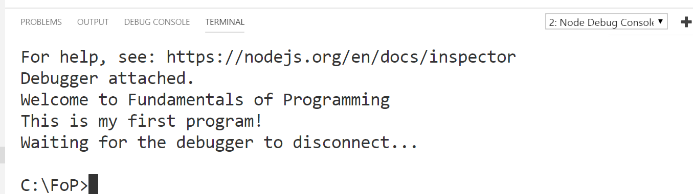
Program Output

3. Testing Program Input.

a) Show Explorer side bar by choose View → Explorer from the main menu.

- Create a new JavaScript file, called "TestInput.js", in Practical02 folder.

- Type in the following code:
var readline = require('readline-sync');
var name = readline.question("What's your name? ");
console.log("Hello " + name + ",\nIt is a good day today");

- Run your program and you will see that now your program is able to accept user’s input.
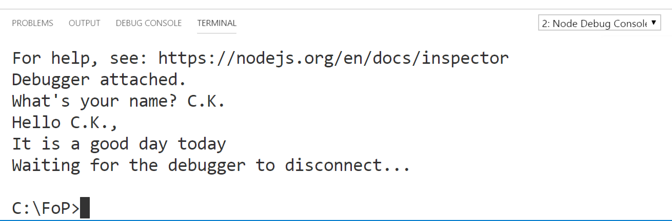
User’s input

4. Write a program called Initials.js that prints your initials as block letters. For example, if your name is Remy Martin, the program should print “RM”.

****** * *
* * ** **
* * * * * *
****** * * * *
** * * *
* * * *
* * * *
* * * *

-- End --

